DigiSkills 3.0 – DBI101
Hands-on Exercise No. 1
Student Name: Zain Ul Abidin_______
Batch: Batch-03

Task 2: XLOOKUP Implementation
Objective:
To fetch Sales, Quantity, Discount, and Profit data from another workbook using XLOOKUP based on Product Name.
Formula Used:
=XLOOKUP(A2,'Sales Data'!A:A,'Sales Data'!B:B)
(Similarly applied for Quantity, Discount, and Profit)
Explanation:
XLOOKUP is used to search for the product name in the Sales Data sheet and return the corresponding values for Sales, Quantity, Discount, and Profit.
Screenshot:
(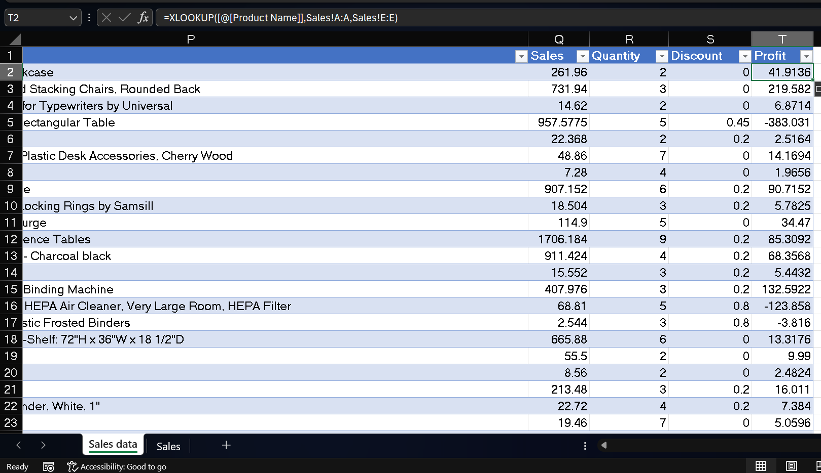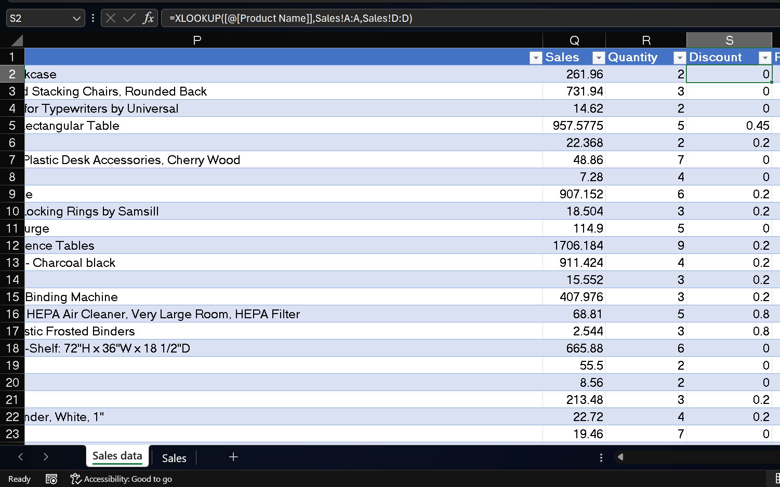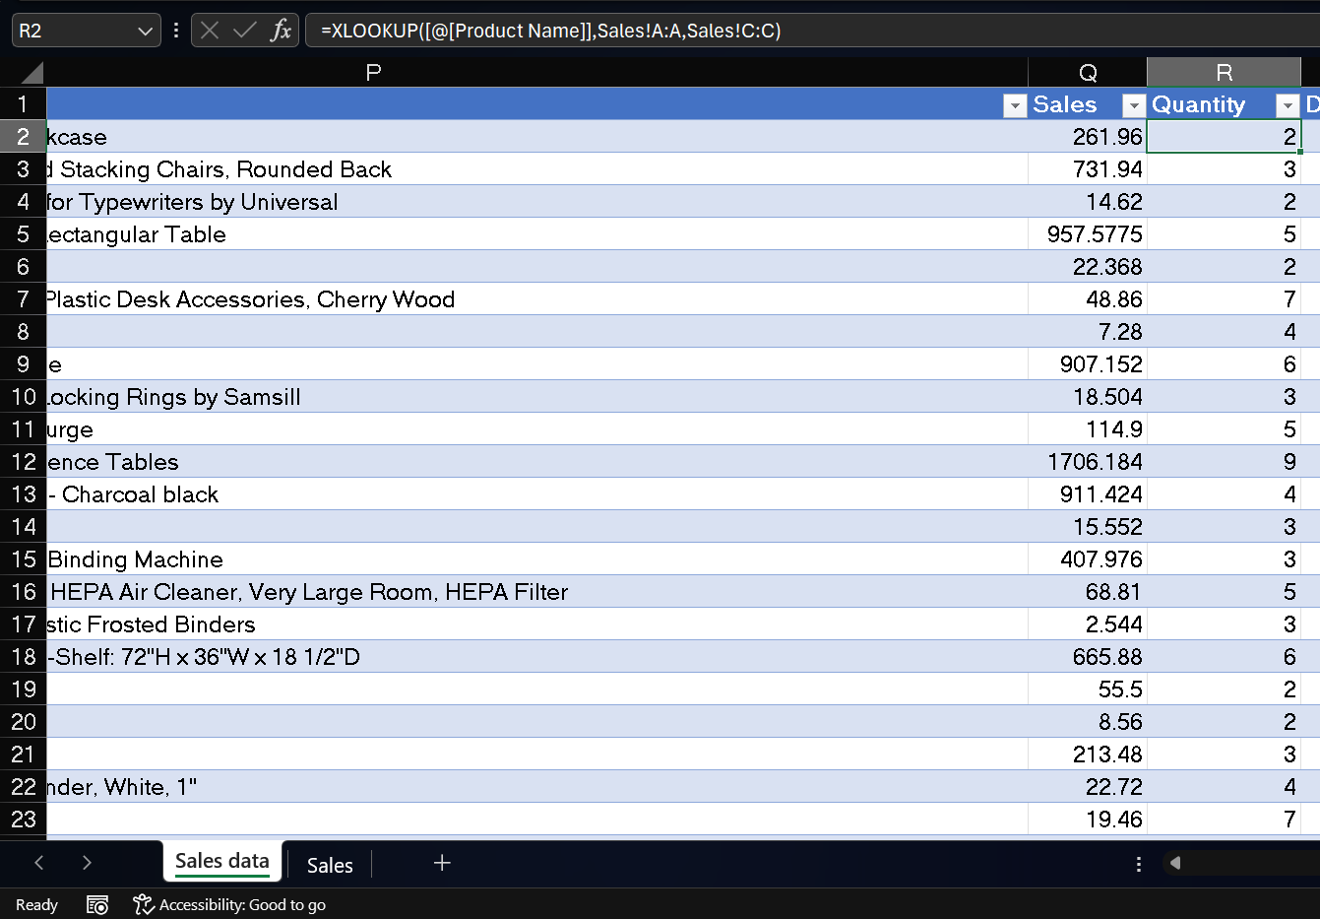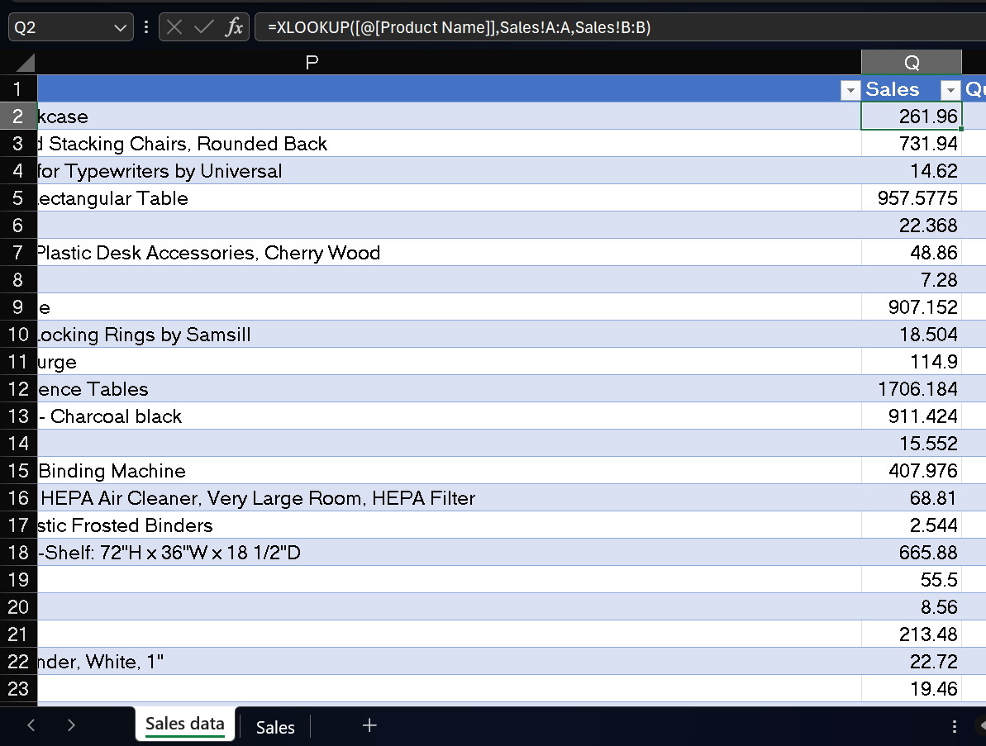

Task 3: Conditional Formatting
Objective:
To highlight Sales values greater than 100.
Steps Performed:
- Selected Sales column
- Applied Conditional Formatting → Highlight Cells Rules → Greater Than → 100
Explanation:
This helps in quickly identifying high-performing sales values.
Screenshot:
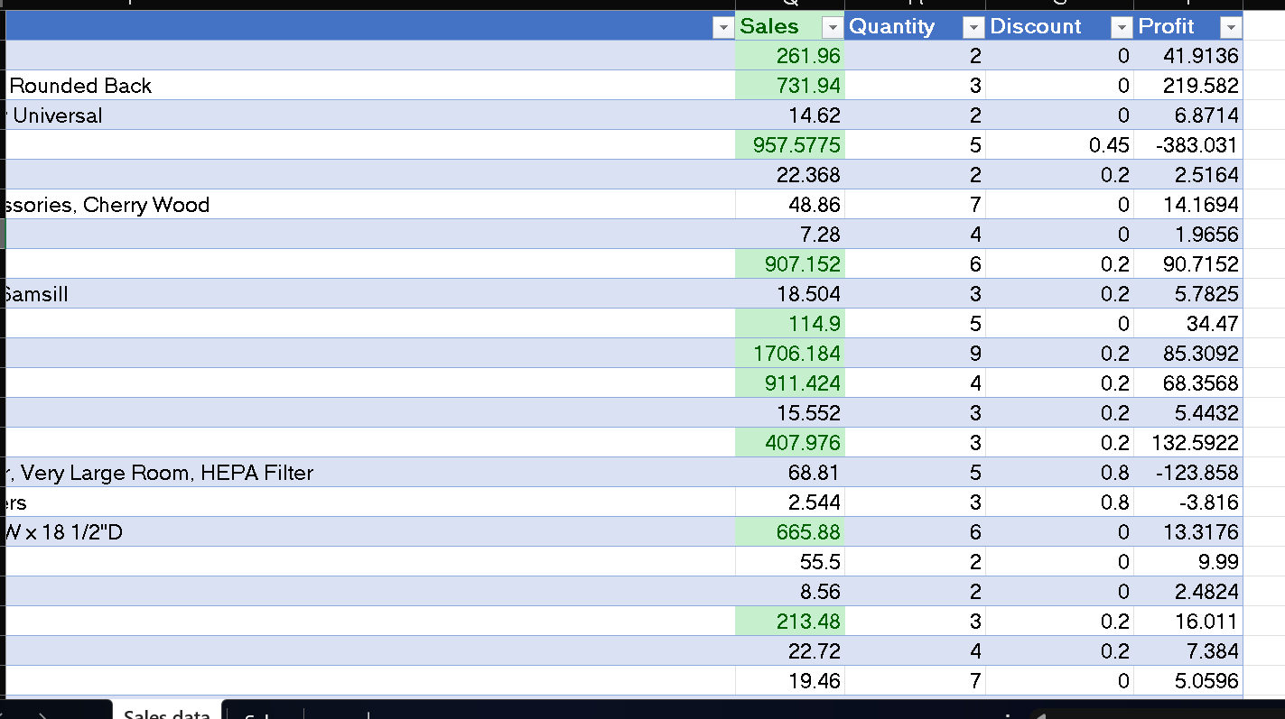

Task 4: Pivot Table
Objective:
To summarize total Sales by Category.
Steps Performed:
- Inserted Pivot Table
- Rows: Category
- Values: Sales (Sum)
Explanation:
Pivot Table provides a summarized view of total sales across different categories.
Screenshot:
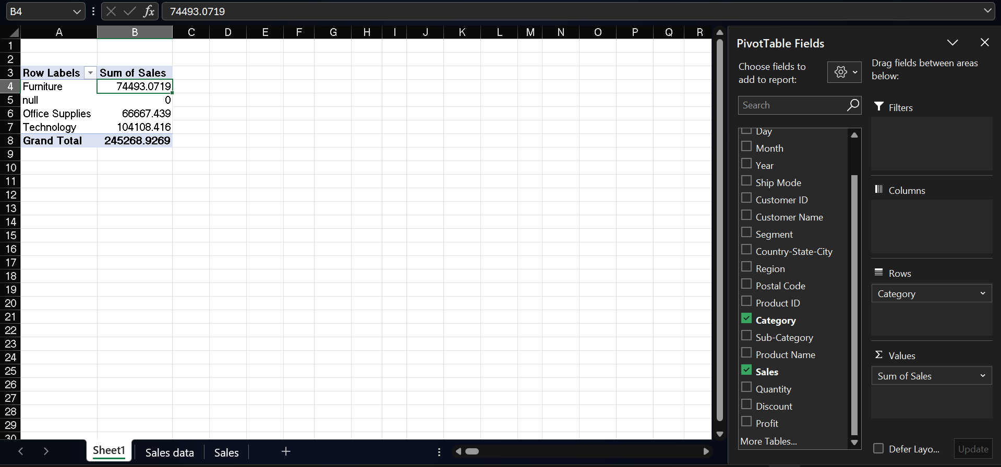

Task 5: Pie Chart
Objective:
To visualize total Sales by Category.
Steps Performed:
- Inserted Pie Chart based on Pivot Table data
- Added chart title and data labels
Explanation:
The Pie Chart visually represents the contribution of each category to total sales.
Screenshot:
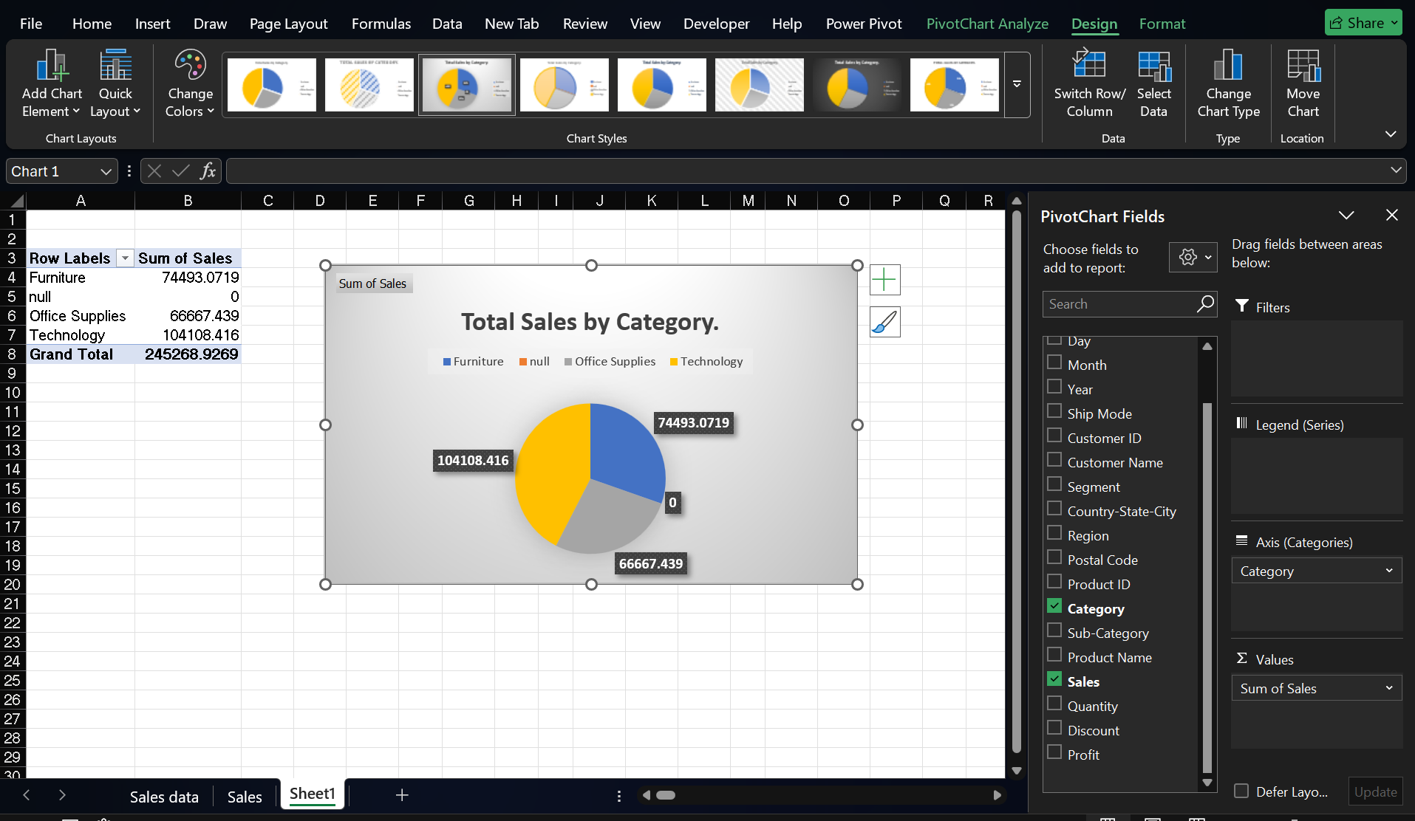

Conclusion
In this exercise, we successfully:
- Combined data using XLOOKUP
- Highlighted important values using Conditional Formatting
- Summarized data using Pivot Table
- Visualized insights using Pie Chart
These techniques are essential for effective data analysis and business decision-making.

